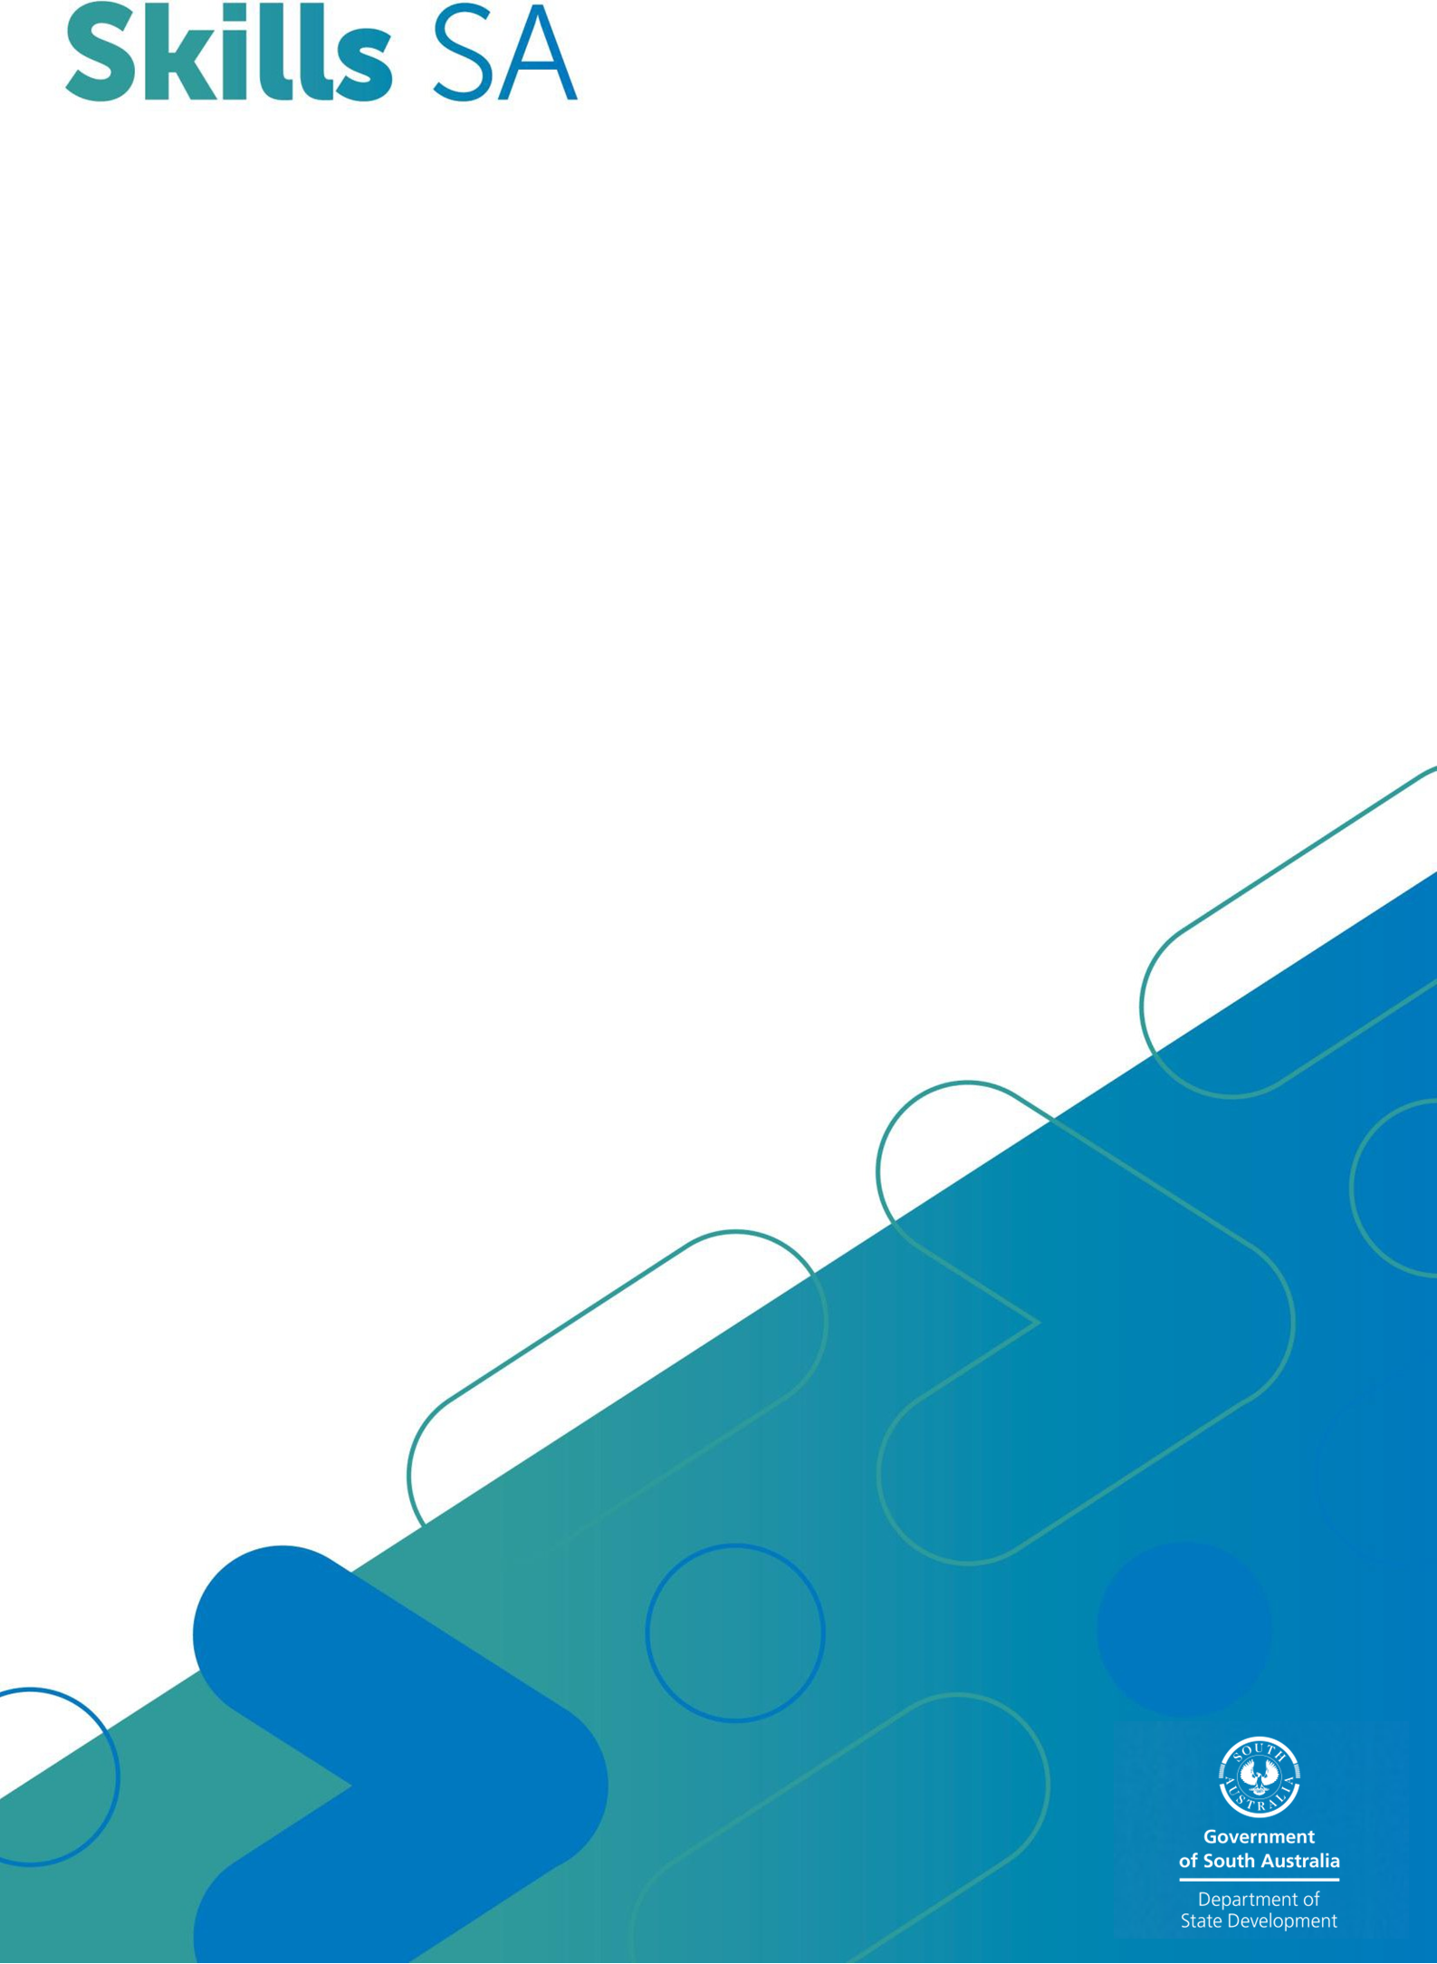
Skills & Employment Portal

User Guide
Submitting Accredited Training Data and Claiming Payments

Version 3.0 – Release date: May 2026

Version | Date | Comments
3.0 | May 2026 | Routine update
2.5 | Jan 2023 | Routine update
2.4 | Nov 2021 | Amend AVETMISS data close-off date
2.3 | Oct 2020 | Routine update
2.2 | Dec 2019 | Routine update.  Merged from two previous User Guides

For further information or assistance in using the Skills & Employment Portal, please email SkillsContracts@sa.gov.au.

Important Note: This is general information only. It does not in any way amend, vary or waive any terms and conditions of the Funded Activities Agreement (FAA). Where the content of this User Guide is inconsistent with the FAA or the Training Fee Framework or where an organisation is not clear on their responsibilities under the FAA, the organisation should seek advice from Skills SA.

Contents

1. Purpose 4
2. Data Submission and Payments Overview 5
3. Training Accounts and Completion Payments 7
4. AVETMISS Data Submission in STELA 8
4.1 AVETMISS Compliance 8
4.2 Data submission 8
4.2.1 Cut-off date 8
4.2.2 Fund Source Identifier 8
4.2.3 AVETMISS data submitted but not processed to payments 8
4.2.4 Edit a claim 9
4.2.5 Academic Pass (Result Code 70-AP) 9
4.2.6 STELA Support and Assistance 9
5. AVETMISS data matching with Training Account data 10
5.1 AVETMISS data 10
5.2 Training Account data accuracy 11
6. View Claim Items and Error Reports 12
6.1 Export Claim Items and Error Reports 12
6.2 Claims with a zero-payment value 16
7. Reconciliation of Accredited Payments to AVETMISS data 17
8. Support and Assistance 17
9. Appendix 1: Fields within claim export file 18
10. Appendix 2: Fields within Error Report 19
11. Appendix 3: Validation and Payment Error Codes 20
11.1 Validation rules 20
11.2 Payment Rules 22
11.3 Calculation Rules 24

Purpose
The Skills & Employment Portal (Portal) allows RTOs to create Participant Profiles, create and maintain Training Accounts, and view payment history.
This User Guide explains:
- how Participant Profiles and Training Accounts are linked.
- the need to align AVETMISS data submitted through STELA with Training Account data in the Portal.
- the process for submitting accurate and compliant subsidy claims; and
- common errors and how to rectify them.
To access subsidy payment for an eligible participant, RTOs must:
  - create a Participant Profile (or validate an existing Profile) and establish a Training Account in the Portal.
  - ensure all AVETMISS data exactly matches the Participant information recorded in the Training Account, as discrepancies will result in errors and prevent claims from progressing; and
  - create the Training Account before commencing training delivery. Units of competency commenced prior to the Training Account creation date are not eligible for payment.
Data accuracy is critical to the successful submission of a claim. RTO staff responsible for data management should contact Skills SA’s Contract Quality and Compliance (CQC) team by emailing SkillsContracts@sa.gov.au if clarification or support is required.
This User Guide should be read in conjunction with:
  - Your current Funded Activities Agreement (FAA) and relevant Funded Activities Annexure - STL Delivery.
  - the Training Fee Framework.

Data Submission and Payments Overview
Contracted RTOs can access accredited training payments for eligible participants, provided that the RTO has fulfilled all its obligations under the FAA and submitted AVETMISS data that is complete, accurate and compliant with the AVETMISS VET Provider Collection specifications.
AVETMISS data must be submitted into STELA by 5.00pm on the second Friday of each month (unless notified otherwise). Data submitted for payment purposes must continue to be reported for the full AVETMISS collection calendar year.
Skills SA monitors data integrity from both current and previously paid data to identify changes from earlier submissions. Errors and unresolved data may result in the recovery of training subsidies.
RTOs can monitor the progress of their AVETMISS submissions in STELA. Any issues relating to AVETMISS data submission should be directed to the STELA Helpdesk.
Once claims are collected, assessed and finalised by the end of each month, the relevant ‘Subsidised Training History’ sections will be updated on the Portal. Claim Items and Error Reports will also be available for download and review.
Successful generation of a payment claim depends on:
- accurate and complete Participant and Training Account data.
- compliant, accurate and complete AVETMISS data submitted in STELA; and
- matching of relevant data elements between the Training Account and AVETMISS submissions.
Details of training subsidies, including payable result codes, fee calculations and completion payments are set out in the Training Fee Framework.
Figure 1 illustrates the stages of the data process, from AVETMISS data submission through to claim assessment and payment.

Data Submission

Load AVETMISS data
For assistance with AVETMISS
reporting, contact the STELA Helpdesk

Data checked by AVETMISS Compliance

System Process

Data matched to Training Account and Subsidy Calculations

Claim Assessment and Payment Approval

Claim view
Claim View in S&E Portal for RTOs
Claim Assessment and Payment Authorisation
For assistance with accredited training payments, contact the CQC team

View Claim on screen

View Payment breakdown on screen

Export of Claim data and Error Reports

Figure 1 - Stages of the AVETMISS data submission, Training Accounts and Payments.

Training Accounts and Completion Payments
Once an enrolment has been established with the participant, your RTO must create a Participant Profile (or validate an existing one) and create a Training Account. Any training commenced prior to the Training Account creation date is not eligible for payment.

For details on how to create a Participant Profile and Training Account, refer to the User Guide for Participant Profile and Training Account Management.

In addition to the training subsidy, Skills SA may pay a Completion Payment, as per the Training Fee Framework. The payment amount will vary according to the type of course.
Before submitting a claim for a completion payment through STELA, your RTO must update the participant’s Training Account status to ‘Qualification Issued’, and record the required parchment details in the Portal as follows:
- Search for the participant’s Training Account and select ‘Edit’.
- Under Summary Information, update the Training Account Status to ‘Qualification Issued’.
- Record Parchment Number and Parchment Issued Date, and
- Select ‘Save’.
Once saved, the Training Account status will be updated to ‘Qualification Issued’. No further edits can be made to the Training Account.

AVETMISS Data Submission in STELA

AVETMISS Compliance
All training activity data must comply with the national AVETMISS VET Provider Collection Specification and the AVETMIS Standard. Data that is incomplete, inaccurate, or non‑compliant will not progress to claim assessment or payment.
Each AVETMISS submission must include the full set of training activity data for the applicable calendar year, up to the date of submission, in accordance with AVETMISS collection requirements.

Data submission

Cut-off date
For payment purposes, AVETMISS data must be submitted into STELA by 5.00pm on the second Friday of each month (unless notified otherwise). The data will be used to validate training activity, calculate payment values for each resulted Unit of Competency and generate a claim. Skills SA will then process payments within the month.

Fund Source Identifier
RTOs reporting training activity in SA via STELA must include the relevant state Fund Source Identifier (FSI). Generally, for accredited training delivered under the STL program, the FSI to use is WRG.
If you are unsure which FSI to use, please refer to Item 4 of your Funded Activities Annexure or contact the CQC team for assistance.

AVETMISS data submitted but not processed to payments
The accredited training payments process collects all AVETMISS-compliant data submitted against payable Fund Source Identifiers and matches with the corresponding Training Account data for each eligible participant in the Portal.
To ensure accuracy, consistency, and eligibility for subsidy payment, all collected data is assessed against a defined set of Validation Rules and Payment Rules. These rules confirm that the data is compliant and that the RTO is entitled to receive a subsidy.
AVETMISS records that fail any Validation or Payment Rule are systematically declined and excluded from payment. Records that pass all rules will proceed to further manual review, where they may be recommended for payment or decline.
A comprehensive list of Validation and Payment Rules is provided in Appendix 3.

Edit a claim
If an RTO identifies an error in the reported data after submission, they must email SkillsContracts@sa.gov.au within two business days to request that the claim be declined. Once a claim has been assessed and approved for payment by Skills SA, it cannot be cancelled or declined.
Errors identified during the claims process can be rectified in your Student Management System (SMS), where appropriate. Amended data must be submitted in the next AVETMISS reporting period and will be assessed as part of the subsequent pay run.

Academic Pass (Result Code 70-AP)
In some cases, contracted RTOs can attract payment for Result Code 70-AP (Academic Pass) as per the Guiding Principles for Result Code 70-AP.
A list of 70-AP payable units is available here. For these units of competency only, the full subsidy will be paid for the AVETMISS result code 70 accompanied by Academic Pass – AP recorded against the Outcome Identifier Training Organisation in the AVETMISS NAT00120 Enrolment File, where a participant has successfully completed the off-job component.
Once the Participant has been assessed for both off and on-job components, the RTO must convert the 70-AP to a finalised outcome, being:
- 20 (Competency Achieved/Pass) where the competency is achieved.
- 30 (Competency Not Achieved/Fail) where the competency is failed; or
- 40 (Withdrawn/Discontinued) where the competency cannot be assessed on-job.

RTOs who do not use NAT files, but enter their results directly in STELA, can select the Academic Pass result from the drop-down box on the resulting screen. Similarly, these RTOs should change the result code from 70-AP (payable) to a finalised result code 20, 30 or 40 as described above and amend the end date. Such conversions will not generate any further payment for that Unit of Competency.
A qualification must not be issued before all 70-AP result codes are updated with valid AVETMISS result codes.

STELA Support and Assistance
For assistance in submitting your AVETMISS data via STELA, please contact the STELA helpdesk by email: stelahelpdesk@sa.gov.au.

AVETMISS data matching with Training Account data
AVETMISS data submitted via STELA must be compatible and linked with data in the Training Account for each participant. If the AVETMISS data does not exactly match with the Training Account data, it will not proceed to payment assessment. This means that RTOs must ensure that the NAT files are accurate when uploading or direct data entry in STELA.

AVETMISS data
Contracted RTOs must ensure that:
- Each AVETMISS data submission includes the full set of training activity data for that calendar year’s AVETMISS Collection, to that point.
- A correct Fund Source Identifier for the relevant program is selected, as per Section 4.2.2.
- The Activity Start Date for the Unit of Competency must be either on or after the Training Account creation date.
- The Activity End Date for the Unit of Competency must be after the Training Account creation date and before the Training Account end date.
- The Activity Start and End Dates reflect the actual period of training and assessment delivery for the Unit of Competency.
- The Outcome Identifier - national (result code) must be accurate. A subsidy will only be paid for a payable AVETMISS Outcome Identifier - national (result code), as per your FAA and the Training Fee Framework.
- The Delivery Location Identifier must specify the location where the training is delivered, as per the Training Fee Framework. For classroom and employment-based delivery, the delivery location Identifier is the predominant location where the training is conducted. For electronic and correspondence based delivery, the Delivery Location Identifier must specify the predominant location where the training is coordinated. The Identifier is cross-referenced to the valid suburb and postcode within the NAT00020 file (or registered Delivery Location within STELA for manual entry by RTOs).
- Bridging Units: For STELA NAT Upload RTOs: If claiming for a bridging unit, the NAT00120 file should connect the bridging unit to the Qualification identified in the Training Account. For STELA manual entry RTOs: Ensure the bridging units are added to the qualification within STELA and the funding source/type assigned to the units.
- Multiple Failed Attempts – Activity Start and End Dates. Once a participant receives an AVETMISS Result Code 30 (Competency not achieved/fail) or 52 (RPL not granted), your RTO may claim funding for a maximum of two further attempts in the same or equivalent Unit of Competency, so long as each attempt includes enrolment, training delivery, and the assessment of all requirements of the unit occurring within the Activity Start Date and Activity End Date reported in STELA.
Specifically, the second or third payment for an additional attempt may only be claimed if:
1) the participant had initially attempted all the requirements for the Unit of Competency and has been assessed as ‘Competency not achieved/fail’ or ‘RPL not granted’; AND
2) the participant has subsequently re-enrolled in the Unit of Competency, undertaken further training and been re-assessed for all requirements in the Unit of Competency.
If claiming a second or third attempt, the Activity Start Date and Activity End Date must be different, distinct and not overlap for each attempt.

Training Account data accuracy
Training Accounts must be accurate and complete. In particular:
- Course Code and the RTO Student ID must be an absolute match with AVETMISS data, as detailed in Section 3.1.
- Training Accounts must be established before the No New Enrolment date as listed on the Subsidised Training List.
- Commonwealth Government Concession Card type – the concession reimbursement will only be calculated for eligible students if this field is entered correctly.

View Claim Items and Error Reports
Once a claim has been assessed and a payment has been made to RTOs, the relevant data will be available for viewing and export through the Claim Items and Error Reports.
As required by the FAA, your RTO is required every month to:
- download the Claim Items Report and verify that data submitted for payment in the most recent pay run was accurate, and
- download the Claim Errors Report and rectify any errors blocking payment where applicable.

Export Claim Items and Error Reports
- From the Portal menu, select ‘Claims’, then ‘Claims Search’ as per Figure 2 below:

Figure 2 - Screenshot of Skills and Employment Portal - Claim Search menu

- Your Claim Details screen is then displayed as shown in Figure 3:
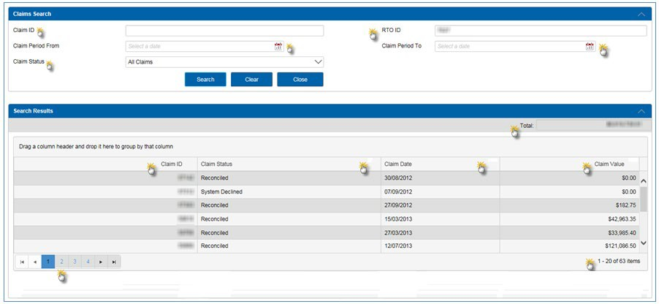
Figure 3 - ’Claims Search’ details on display

Fields in Figure 3 | Explanation
Claim ID | A unique claim number assigned to each new claim. This will automatically populate when you select a particular claim as per Figures 4 and 5.
RTO ID | Your RTO Code as per Training.gov.au
Claim Period From | These fields provide a calendar for easy date selection and entry. However, if these fields are left blank, you will retrieve all claims for your organisation, both current and non-current.
Claim Period To | As above.
Claim Status | RTOs will see their claim in the Portal when the status is ‘Reconciled’ or ‘System Declined’. When reconciled, the payment has already occurred.
Search Results Fields
Total | Value displayed is based on search criteria
Claim ID | A unique claim number assigned to each claim, which can be filtered as displayed.
Claim Status | Displays the status of the claim, which can be filtered as displayed.
Claim Date | Displays the date of the claim, which can be filtered as displayed.
Claim Value | Displays the claim value of claims, which can be filtered as displayed.
Page Navigation | Allows you to navigate pages to view claims on other pages
Number of Items Retrieved | Displays the number of items retrieved

- Once you have selected the ‘Claim Status’ type and the relevant ‘Claim Period’ click the ‘Search’ button to view details of your claim on screen. A sample result is shown in Figure 4 below.
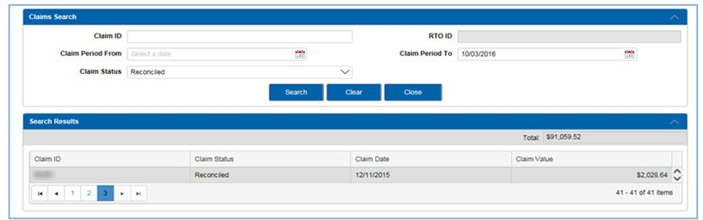
Figure 4 - Sample of Claim Search results

- By double clicking on the row of the selected ‘Claim ID’, you will see a summary of the claim by qualification and the calculated payment values against each qualification as per Figure 5 below. You will also notice that each qualification within the claim is also a linked field.
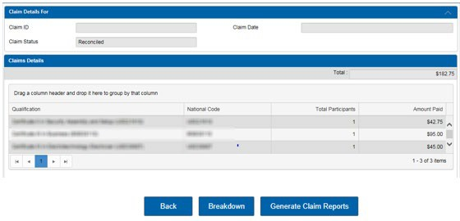
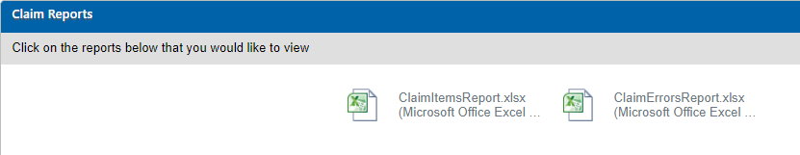

Figure 5 - Summary of the Claim via clicking on the row of the selected ‘Claim ID’

Buttons | Functions
Breakdown | Shows a breakdown on screen of the subsidies and loadings paid.
Back | Takes you back to the previous screen.
Generate Claim Items Report | Generates a report in Excel Format, of all payable items in the claim, including those that have been declined during the manual payment review process. Appendix 1 contains a list of the report fields and descriptions.
Generate Errors Report | Generates a report in Excel Format of all Validation and Claim Errors, see Appendix 2 for a list of the fields in this report. The report summarises the errors that may exist against your Training Account or against each Claim Line Item by Course, Participant, and Unit of Competency. Appendix 3 contains a list of Error Codes and Descriptions.  Note: This report does not include claims that have been assessed and declined during the manual payment review process. These will be in the ‘Claim Items Export’ report.
These export reports will assist to identify any data issues that are able to be corrected before the next claim collection. Remember, when correcting any errors, it is important to make these changes in the administrative system you use to manage your participant and/or your AVETMISS data. Then repeat the data submission process (if necessary) in STELA.
Note: Some errors are old and unable to be fixed. You are recommended to maintain the main register to track all existing errors and add them into the new Error Report each month, to make it easy to identify which errors are new and require attention.
Within your usual reports, each error is reported for every Unit of Competency included in your AVETMISS data, so once the issue is resolved at the Training Account level, all activities will progress for payment review in the subsequent payment run.

- Double click on a row for a ‘Qualification’ to generate a list of participants in the Claim against that selected course.
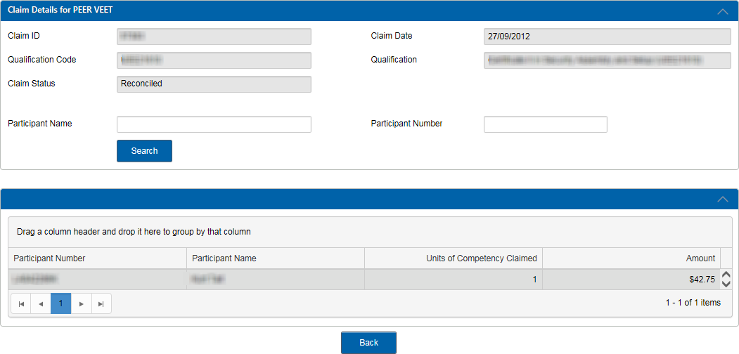
Figure 6 – Qualification drill down view

- You can view or drill down further to the Unit of Competency level and see details of a Unit of Competency and any payment or error code. Double click on a row for a participant to view these details. A further breakdown can be provided to provide the payment breakdown details for the highlighted Unit of Competency.
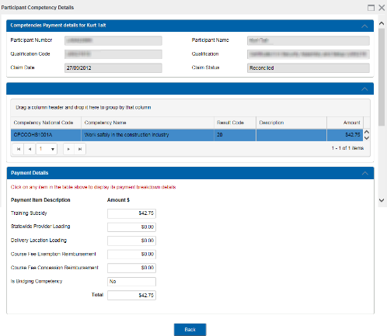
Figure 7 – Participant drill down view

Claims with a zero-payment value
For claims that result in a zero-payment value, it is important that RTOs export the Claim Errors Report which will then provide a list of errors requiring attention.
All errors resulting in a zero-payment value will be re-assessed in subsequent payment runs. It is therefore important for RTOs to ensure that all corrections are made in their Student Management System and that the amended NAT files are uploaded to STELA (for upload RTOs) or manually entered prior to the next cut-off data submission date.

Reconciliation of Accredited Payments to AVETMISS data
RTOs may seek to amend AVETMISS data after accredited training payments have been made. Where a previously payable result is amended to a non-payable result, the discrepancy is captured in the Data Reconciliation Report.
Skills SA regularly reconciles accredited training payments against AVETMISS data. Where discrepancies are identified, the team will liaise directly with RTOs to resolve the issue or to initiate recovery where required.
More detailed reviews are undertaken later in the calendar year until after the AVETMISS annual submission cut-off date in January of the following year. Skills SA will check for any changes to previously paid AVETMISS data where:
- A student enrolment was paid but is no longer being reported in STELA; or
- A student enrolment was paid against a payable Fund Source Indicator (WRG, TGS or EPA), but the Fund Source Indicator has subsequently been amended to a non-payable one (FFS); or
- A student enrolment was paid against a payable AVETMISS Result Code (20, 30, 51 or 70-AP), but the Result Code has subsequently been amended to a non-payable one (i.e. 70 – Continuing Enrolment or 40 - Withdrawn).
RTOs will be sent a report showing any discrepancies identified in their data and given opportunities to respond and make any necessary corrections to AVETMISS data. Clause 28 of the FAA’s Training Schedule specifies that funding may be recovered where data was not complete, compliant and accurate as required by AVETMISS.

Support and Assistance
If you experience trouble logging into or require assistance with using the Portal, please contact the Contract Quality and Compliance team by email to SkillsContracts@sa.gov.au.
Your feedback and comments are welcome so that we can continuously improve the Portal to meet the needs of our clients.

Appendix 1: Fields within claim export file

Export Field | Description
Claim ID | Claim ID assigned to your claim
Claim Date | Date the claim was generated
Training Account ID | Unique System ID linked to Training Account
Claim Line Item ID | Unique transaction key assigned to the Unit of Competency in the claim
RTO Code | Unique National ID assigned to the RTO as per Training.gov.au
Trading Name | RTO’s Trading Name
Participant ID | Participant ID
RTO Student ID | RTO’s unique student number
TCID | Training Contract ID (for Apprentices or Trainees) stored in the Participant Training Account
Participant Surname | Participant Surname
Participant First Name | Participant First Name
Participant Other Name | Additional names assigned to the participant
Date of Birth | Participant Date of Birth
National Course Code | National qualification code assigned to the qualification undertaken by the participant
Course Name | Qualification Description
Competency Code | National code assigned to the Unit of Competency undertaken by the participant
Training Start Date | The reported training start date of the Unit of Competency
Training End Date | The reported training end date of the Unit of Competency
AVETMISS Result Code | AVETMISS Unit of Competency Result code
Field of Education | Identifies the area of learning pertaining to the course
Payment Type | Competency or Qualification
Transaction Type | Payment (only Transaction Type currently)
Claim Line Item Status | Status assigned to the Claim Line Item  (System Declined, Approved, Reconciled or Declined)
Amount to Pay | Total amount payable
Error Code | Error code identifier assigned to the claim line item
Error Description | Description of the error against the claim line item  (See Appendix 3 for more information and suggested treatments)
Assessment Outcomes | Manually assessed outcome
Work Group | Used by the RTO to identify workgroup responsible for participant delivery and assessment
Concession | Eligible concession reimbursement
Training Subsidy | Subsidy Paid
State-wide Provider Loading | Loading paid for state-wide delivered training
Delivery Location Loading | Loading paid for training delivered in a remote location
Course Fee Exemption | Eligible exemption reimbursement
Qualification Completion Payment | Eligible completion payment

Appendix 2: Fields within Error Report

Export Field | Description
Contract Expires | Date your contract expires
Claim Date | Date the claim was generated
RTO Code | Unique National ID assigned to the RTO
Training Account ID | Unique System ID linked to Training Account
Training Account Status | Status assigned to the Training Account: Active with Activity, Active with no Activity, leave from Enrolment, Qualification Issued, Terminated Agreement (Closed)
Participant ID | Participant ID
RTO Student ID | RTO’s unique student number
Participant Surname | Participant Surname
Participant First Name | Participant First Name
Participant Other Name | Additional names assigned to the Participant
Date of Birth | Participant Date of Birth
National Course Code | National code assigned to the qualification undertaken by the Participant
Course Name | Qualification Description
Competency Code | National code assigned to the Unit of Competency undertaken by the Participant
Training Start Date | The reported training start date of the Unit of Competency
Training end Date | The reported training end date of the Unit of Competency
AVETMISS Result Code | AVETMISS Unit of Competency Result code
Provider Result Code | RTO’s Unit of Competency Result code
Delivery Location Post Code | Delivery Location Post Code
Delivery Location Suburb | Delivery Location Suburb
Qualification Issued Flag | Flag used to indicate if the qualification has been issued
Error Code | Error code identifier assigned to the claim line item
Error Description | Description of the error against the claim line item  (See Appendix 3 for more information and suggested treatments)
Location Classification | Classification applied to the delivery location
Location Loading | Loading paid for training delivered in a remote location
Provider Participant Fee | Participant fee as indicated in the Training Account
Provider Participant Hours | Participant delivery hours as indicated in the Training Account

Appendix 3: Validation and Payment Error Codes

Validation rules
The Validation Rules are used to ensure data imported into the Payment Assessment process is valid, consistent and accurate prior to being processed.

Payment Rule ID | Error Description | What this Means | Suggested Treatment
1001 | Duplicate record | Two identical records have been reported in the AVETMISS Submission | Review data to ensure no duplicate records are submitted in your AVETMISS data.
1002 | Conflict record | Two records have been reported in the AVETMISS Submission which counter act one another | Review data to ensure no conflicting UOC records with overlapping dates for the same Participant, are submitted in your AVETMISS data.
1004 | Qualification Not Found | Unable to locate a matching Qualification for the Participant | Review your AVETMISS and Training Account data for the correct Course / Qualification and re-reported.
1006 | Competency Not found | Unable to locate an approved Unit for the AVETMISS Submission | Review your AVETMISS data for this Unit of Competency. This Unit of Competency Code is not eligible against this Course / Qualification.
1007 | Location not found | Unable to locate a matching Suburb AND Postcode for the “Delivery Location” information within a Providers AVETMISS Submission | Review the combination of suburb and postcode used for the delivery location. Combination in AVETMISS data is not valid.
1008 | Training Account not found | Unable to locate a matching Training Account against information within the AVETMISS Submission | AVETMISS data must match the Training Account. Check that the Student RTO ID and Course / Qualification code in your AVETMISS data matches the information against the Participant Training Account.
1009 | Participant not found | Unable to locate a matching Training Account for the Participant in the AVETMISS Submission | AVETMISS data must match the Training Account. Check that the RTO Student ID and Course / Qualification code in your AVETMISS data matches the information against the Participant Training Account.
1010 | Qualification code missing | AVETMISS Submission does not include a “Qualification Code” | Review your AVETMISS data for this Course / Qualification. The Course / Qualification code is missing.
1012 | Internal unique ID missing | AVETMISS Submission does not include an RTO Student ID | Review your AVETMISS data for this participant. RTO Student ID is missing.
1013 | Competency code missing | AVETMISS Submission does not include a Unit of Competency Code | Review your AVETMISS data for this Unit of Competency. Unit of Competency Code is missing or incorrect in your submission.

Payment Rule ID | Error Description | What this Means | Suggested Treatment
1014 | Training Start Date missing | AVETMISS Submission does not include the required “Training Start Date” for this record | Review your Unit of Competency’s training start date in your AVETMISS Data.
1015 | Training Finish Date missing | AVETMISS Submission does not include the required “Training Finish Date” for this record | Review your Unit of Competency’s training end date in your AVETMISS Data.
1017 | Participant Date of Birth missing | AVETMISS Submission does not include a “Date of Birth” for this participant | Review your AVETMISS data for this Participant. Participant Date of Birth is missing.
1019 | Location Suburb missing | AVETMISS Submission does not include the required “Delivery Location Suburb” for this record | Review your AVETMISS data for this Participant. Delivery Location Suburb is missing.
1020 | Location Postcode missing | AVETMISS Submission does not include the required “Delivery Location Postcode” for this record | Review your AVETMISS data for this Participant. Delivery Location Postcode is missing.
1021 | Organisation does not have an active contract | RTO does not have an active Contract

Payment Rules
The Payment Rules are used to validate whether an RTO is entitled to receive a payment for a completed Qualification or Unit of Competency as per the current FAA.

Payment Rule ID | Error Description | What this Means | Suggested Treatment
PR210B | Qualification completion payment cannot be paid unless the Training Account status is set to Qualification Issued. | The Training Account for this Participant has not been updated to reflect that the Qualification is complete. | Update the status of the Training Account to 'Qualification Issued'; Record the Parchment Number and issued date; and  The Course / Qualification meets Completion payment criteria.
PR1000A | Maximum number of Units of Competency required for this Qualification has been funded | Maximum number of units of competency for this course has been subsidised. | This information is viewable in the Participant funded training history in Portal.
PR1000B | Maximum number of Bridging Units have been funded | The maximum number of bridging units for this Participant has been subsidised. | This information is viewable in the Participant funded training history in Portal.
PR1020A | Unit start date is prior to contract start date | RTO is reporting units that commenced before their contract was executed | Any training activity that commenced prior to the execution of your Contract is not eligible for subsidies.
PR1020B | Unit start date is after Training Account end date | RTO is reporting units with a training start date after the End Date of the Training Account | Any training activity that is completed before the date the Participant’s Training Account is created is not eligible for subsidies.
PR1020B | Training Accounts created on or After 1/3/2016: Unit end date is after the  Training Account end date | RTO is reporting units with training end date after the Training Account end date | Any training activity that ends after the date the Participant’s Training Account is terminated or qualification issued is not eligible for subsidies.
PR1020C | Unit end date is before the Training Account create date | Provider is reporting units with training end date before the Training Account create date | Any training activity that ended before the date of the Participant’s Training Account is created is not eligible for subsidies.
PR1020C | Training Accounts created on or After 1/3/2016  Unit start date is before the Training Account create date | The unit start date must be on or after the Training Account create date | Any training activity that commenced before the creation date of the Participant’s Training Account is not eligible for subsidies.
PR1030A | Participant has already passed this Unit | This Unit of Competency has already been subsidised | The Unit of Competency for this Participant has already been subsidised. This information is viewable in the Participant’s subsidised training history in Portal.

Payment Rule ID | Error Description | What this Means | Suggested Treatment
PR1030B | Participant has exceeded 3 paid attempts in this Unit | This Unit of Competency has exceeded maximum subsidised attempts | The maximum number of attempts for this Unit of Competency, for this Participant has been subsidised.  This information is viewable in the Participants subsidised training history in Portal.
PR1040 | Course completion payment has already been issued for this Course | A completion payment for this course has already been subsidised | The Course completion payment for this Participant has already been subsidised. This information is viewable in the Participant’s subsidised training history in Portal.
PR1050A | AVETMISS Qualification issued date is in the future or null | The Qualification issue date is in the future or missing. | Review the Qualification issue date in AVETMISS data for this Participant.
PR1050B | Qualification issued date is null or before the Training Account created date | The Qualification issue date is missing or prior to the creation date of the Training Account. | Review the Qualification issue date in AVETMISS data for this Participant.
PR1120 | RPL is not payable for this course | RTO is reporting RPL for a unit under a course where RPL is not subsidised | Skills SA does not subsidise outcomes of RPL for this Course.
PR1130 | Unit End Date must not be after Contract Completion Date | RTO is reporting a unit where the training end date is after the providers no new Enrolment Date. | Review AVETMISS data for this Participant. There are results that ended after your Contract Training End Date.
PR1131 | Provider contract has expired or been terminated | RTO is reporting after their FAA has expired or has been terminated
PR1140 | Qualification issued date cannot be after the contract expiry date | RTO is reporting Qualification Completion after their Contract Expiry Date | The Course / Qualification issue date is after the Contract expiry date. Review your Qualification issue date in your AVETMISS data for this Participant.
PR1170 | No Payment on 70AP for this Course | RTO is reporting a 70AP result code for a Unit of Competency which is ineligible for 70AP use | Skills SA does not subsidise outcomes of 70AP for this Unit of Competency.
PR1190 | Unit attempts overlap, this unit start date is within a previous unit attempt start and end date range | RTO is reporting an attempt for a Unit of Competency where both previous unit and the new unit start dates overlap | Review AVETMISS data for this Participant. Additional attempts at a Unit of Competency must have a commencement date which is after the completion date of the Participant’s prior attempt.

Calculation Rules
The Calculation Rules are used to validate the payment value for a Unit of Competency or Completion Payment as per the current contracting arrangement.

Payment Rule ID | Error Description | What this Means | Suggested Treatment
SC601010 | RTO Participant fee value is invalid. | The Training Account for this Participant has a Participant fee  entered that is invalid. | Review the Training Account for this Participant.
SC601011 | RTO Participant hours value is invalid | The Training Account for this Participant has Participant hours entered that are invalid. | Review the Training Account for this Participant.

