Learner Support Services Partnership Agreement
Between [name of LSS provider] and [name and number of RTO receiving LSS] for the period [insert date – 12 month period]

Glossary
In this partnership agreement unless context otherwise requires:
- Common client refers to a student enrolled with [RTO] and who is also accessing Learner Support Services through [LSS provider]
- Eligible student refers to a student who is eligible to access learner support services. Eligibility is described in Appendix B
- LSS provider refers to a service provider contracted by Skills SA to deliver learner support services
- LSS case manager refers to LSS provider staff responsible for delivering learner support services
- PCTS stands for post course transition support
- RTO stands for registered training organisation with a Skills SA funded activities agreement (FAA)
- UAN stands for upfront assessment of need
- VETRO stands for vocational education and training readiness orientation and is the version of the UAN undertaken by school enrolled students when seeking to enrol in a VET course as part of their South Australian Certificate of Education (SACE).

Introduction
Learner support services (LSS) provides, free of charge, non-clinical case management support to VET students, who face complex barriers to sustaining and completing their studies. The provision of LSS is funded by Skills SA to increase the retention of students and remove barriers to completion of their VET course.
LSS providers have been assessed and selected by Skills SA as having the expertise and functional capacity to provide case management support.
Before entering an LSS partnership agreement (the agreement) RTOs must demonstrate that they provide an inclusive, supportive and flexible learning environment as described in the Skills SA student support standards, the Skills SA funded activities agreement (FAA), the upfront assessment of need requirements and, where relevant, the VET readiness orientation (VETRO) process.
RTOs who meet these requirements can enter an agreement for the provision of LSS for students whose support needs are more complex than their existing support provisions can meet.
This agreement outlines the conditions under which [LSS provider] will provide learner support services to eligible students of [RTO] during the period of training and up to 12 weeks of post course transition support (PCTS).

The agreement outlines the roles and responsibilities of both organisations to ensure their common clients receive the best possible services. Both organisations will ensure that eligible students have ready access to learner support services as described in section 4.
The agreement establishes a best practice model for working together to provide quality services to common clients who require LSS assistance to continue to engage effectively with and succeed in their VET course.
Each party shall act diligently and in good faith in the performance of their obligation under the agreement. The agreement does not and is not intended to create legal partnership between the parties. However, the commitments in the agreement form part of Skills SA compliance expectations under the UAN.

FAA compliance requirements
Entering and keeping the agreement up to date is a condition of the UAN and, therefore, a compliance condition of the FAA.
The UAN requires RTOs to submit, and have endorsed by Skills SA, an annual self-assessment of their student supports. For RTOs that demonstrate best practice in accordance with the Skills SA student support standards (support standards), Skills SA may provide written approval to modify the frequency of this requirement.
The Skills SA student support standards - organisational self-assessments (self-assessment) is designed for RTOs to demonstrate that they have processes and practices in place to support the diverse needs of learners in South Australian subsidised training. The self-assessment includes a requirement that RTOs articulate how they use the upfront assessment of need (UAN) process to ensure their student’s support and learning needs are assessed and plans put in place to support them. See the website for the upfront assessment of need and VETRO documents: Training Provider Centre | Upfront Assessment of Need (skills.sa.gov.au)
The self-assessment will be reviewed by Skills SA. If Skills SA considers that the RTO has not clearly articulated existing student supports that meet the support standards, then Skills SA will request the RTO to revise and re-submit until the required support standards have been demonstrated. Once Skills SA has provided endorsement of the self-assessment, RTOs are able to re/negotiate an LSS partnership agreement with an LSS provider/s.
A new agreement cannot be entered if an RTOs self-assessment has lapsed or has not been endorsed by Skills SA. Self-assessments should be revised and submitted to Skills SA two months prior to expiry to ensure a current self-assessment is in place when seeking to re-enter a new agreement.
Adhering to this agreement is a condition of ongoing LSS provision to the referring RTO.

Objectives
This agreement aims to have in place a process where both parties work together to:
  - Ensure there is ongoing communication and sharing of information.
  - Enable [LSS provider] case managers and [RTO] staff to provide services and support for their common clients.
  - Ensure there is coordination of services that the common client may already or could be accessing from another agency or organisation.
  - Determine the best delineation and complementarity of supports offered by each organisation when addressing issues around life, learning and transition while training is being undertaken.

Description of services
  - LSS enables [RTO] to access a service for eligible students over and above their current provision of student support outlined in the Skills SA approved self-assessment.
  - [LSS provider] case managers build collaborative partnerships with external agencies with
the aim of supporting students who have barriers to learning; supporting retention in training and assisting students with complex support needs to complete their qualifications and transition to further study or employment.
  - LSS is not intended to replace existing student support provision by [RTO] but to enhance it. [RTO] will continue to provide supports to its students in accordance with [RTO] approved self-assessment and will work in good faith with the LSS provider to ensure its students can access enhanced supports through [LSS provider].
    - To commence the provision of LSS to a common client:
      - [RTO], on behalf of the student and with their permission, can initiate contact with [LSS Provider] LSS case manager; OR
      - The student can self-refer to [LSS provider] LSS case manager via the contact details provided; AND
      - Each client that is referred by [RTO] or self-refers to [LSS provider] will be assessed for eligibility, refer Appendix A.

4.5 [RTO] ensures all students are aware of and can access LSS through inviting [LSS provider] to attend and introduce LSS at information/induction sessions with all student groups enrolled with [RTO], through including information about LSS in the [RTO] student handbook or equivalent, prominently displaying information about LSS in the learning environment, providing regular reminders to students about the supports that LSS can provide and actively encouraging students to consider LSS as a normal part of the suite of supports they can access.
  - The [LSS provider] LSS case manager works collaboratively with the student, trainer, and
external agency to address the student’s support needs and assist the student to participate
and complete their course and transition into employment or further training.
  - Support needs that students may present with under LSS are categorised into the domains of “Living, Learning and Transitions”. Supports provided can address one or more needs across any or all three domains refer Appendix B. The focus of all support provided is to enable the student to continue with their study.
  - LSS addresses complex issues that may impact on living, learning and transition and provides:
    - liaison and advocacy with [RTO] to ensure best supports are in place for each common client,
    - supported referral and advocacy (e.g. health, housing, legal, Centrelink/employment services provider),
    - in-class and study skills support,
    - personal support, and
    - support can occur during work placements.
LSS post course transition support provides similar supports in an employment or further training environment to support successful transition outcomes.

Delivery venue
  - Learner support services may be provided at any relevant delivery venue and/or work placement venue. Where meetings take place at [RTO], [RTO] will provide a meeting space that ensures privacy and confidentiality.
  - LSS may also be provided at an agreed public venue such as libraries or community centres and may be delivered online or by phone.
  - [LSS provider] LSS case managers may from time to time attend external appointments with [RTO] common clients.
  - Venue used must comply with WHS regulations.

Duration of agreement
  - The agreement will commence when executed by both parties and will continue for 12 months from this date, as specified on page one of this agreement, subject to funding availability. After this period both parties will review the agreement with a view to continuing for a further 12 months, subject to funding availability.
  - The agreement can only be re-negotiated if [RTO] has provided [LSS provider] with confirmation they have updated their annual self-assessment, submitted it to Skills SA for review and received approval in writing.

Termination and variation
  - A current LSS partnership agreement is a condition of compliance with the UAN for all RTOs with a Skills SA FAA.
  - Variations to the agreement will only be made in writing and signed by both parties.
  - Either party may terminate this agreement by giving notice in writing at any time. Termination of the contract will result in cessation of provision of LSS by [LSS provider] for any new students referred (or self-referred) by [RTO]. However, if any current students of [RTO] are receiving LSS, [RTO] cannot abdicate their responsibilities under this agreement in respect of those students until they have exited LSS or have left [RTO], whichever comes first.
  - If the agreement is terminated by either party and [RTO] does not have an agreement with another LSS provider [RTO] must contact Skills SA to discuss the reasons for termination and steps required to enter another agreement with an alternative LSS provider. Skills SA can be contacted at purchaseplanningandstrategy@sa.gov.au
  - This agreement will be renegotiated annually and will include an assessment of whether [RTO] is sufficiently meeting its obligations under this agreement to enable LSS to be effectively delivered to the common clients. [LSS ] will not re-enter a new agreement with [RTO] if [LSS provider] considers it is not being enabled to effectively support the common clients.

Consent of clients
  - Each party confirms that it will not disclose the identity or details of common clients to one another without the completion of the relevant consent form, refer Appendix C. To avoid any doubt, the parties for the purpose of gaining advice, assistance or determining whether a referral is appropriate, may discuss the details of a common client without disclosing the client’s identity.

Confidentiality
  - Each party agrees to keep confidential all information received from the other party including but not limited to information about their common clients.
  - Each party agrees to ensure its staff and related entities comply with the confidentiality and sharing of information requirements of this agreement, the FAA and their organisation’s confidentiality policies and procedures.

Compliance with Law and Government Policy
  - Each party will, at their expense, at all times, maintain all authorisations, licences and consents necessary for each party to provide the services under this agreement.

Liability
  - Each party confirms that it carries out the agreement at its own risk and will not be responsible for any loss or damage another party suffers as a result of carrying out their roles and responsibilities.

Fees and invoicing
  - Learner support services (LSS) is funded by Skills SA. No fees are charged to [RTO] and no fees are charged to the students supported through LSS.

Marketing and advertising
  - [RTO] will obtain Skills SA approval for all advertising content that relates to the provision of learner support services prior to publishing.

[LSS provider] obligations
[LSS provider] will:
  - Ensure that its role is performed in a manner and to a standard that meets the requirements of the Skills SA LSS operational guidelines as well as current legislation relevant to training providers and students (for example the Disability Discrimination Act Education Standards, Privacy Legislation, Work Health and Safety Legislation).
  - Ensure that its employees are aware of and comply with this agreement and are sufficiently skilled and experienced to meet [LSS provider’s] obligations.
  - Ensure [LSS provider] LSS case managers have undertaken all essential training required by the LSS operational guidelines.
  - Provide [RTO] with a copy of the current Department of Human Services (DHS) Police Clearance and Child Safe Environment certificate for its LSS case managers, on request.
  - Provide the amount and level of support required by each common client to sufficiently address issues identified within the support plan.
  - Collect personal information about each common client for the purposes of Skills SA reporting requirements under the LSS contract.
  - Prior to submission of the LSS reporting spreadsheet to Skills SA, provide [RTO] with a copy of a spreadsheet for the purpose of completing any missing client data for any students the RTO has referred to LSS.
  - [LSS provider] agrees that during the term of this agreement it will not solicit business from any client of [RTO] in the State in which [LSS provider] performs services for [RTO] under this agreement

[RTO] obligations
[RTO] will:
  - Ensure that all relevant employees are aware of and comply with this agreement.
  - Undertake to ensure that the agreement will be provided in a manner and to a standard that meets the requirements of current legislation relevant to training providers and VET students (for example the Disability Discrimination Act Education Standards, Privacy Legislation, Work Health and Safety Legislation).
  - Maintain accurate records.

  - Provide [LSS provider] with critical data for Skills SA reporting requirements within 5 working days of the request.
  - Provide eligible students with an opportunity to meet with the [LSS provider] LSS case manager via an agreed introduction process. At minimum this includes providing opportunity for LSS case managers to attend and present information on LSS at induction sessions, online or in-person, for all students.
  - Refer eligible students to LSS and support eligible students to self-refer to the service as required. At minimum this includes providing readily available information embedded in the student handbook or equivalent information to students detailing which LSS provider [RTO] has an agreement with.
  - Communicate with the [LSS provider] LSS case manager to negotiate suitable times for the provision of LSS support including but not limited to; in-class support, external appointments/referrals, and personal support. [RTO] will agree to and support in-class support for students wherever this is practically possible.
  - Complete the current template for ‘Skills SA student support standards – organisational self- assessment’ tool, submit to, and have received approval from, Skills SA for the self- assessment prior to entering or re-negotiating a further LSS partnership agreement, refer to the website: Training Provider Centre | Learner Support Services (skills.sa.gov.au)

Conditions of the agreement
  - No addition or modification of any provision of this agreement shall be binding upon the parties unless made by written instruction signed by the parties.
  - The terms of this agreement commence at the date of execution of the agreement (“the commencement date”) and expires after 12 months, as specified on page one of this agreement.
  - The parties to this agreement acknowledge and express a general willingness to work together in good faith in the spirit of this agreement and to negotiate settlements of all disputes in relation to this agreement.

Personal information
  - In the execution of this agreement, [RTO] agrees to collect from participants, only relevant personal information as per the learner support services requirements. Furthermore, such personal information shall be treated with the strictest confidence and in accordance with the national privacy principles. [RTO] shall not disclose such personal information to any other third party, without prior consent from the individual/s.
18.2 [LSS provider] must comply with the Privacy Act 1988 (Cth) and national privacy principles and treat all personal information received from [RTO] with the strictest of confidence.

Agreement:
RTO trading name:
ABN:
Legal name:
Name and title of authorised officer:

Signature of authorised officer:

Date: 20…………

LSS provider trading name:
ABN:
Legal name:
Name and position of authorised officer:
Signature of authorised officer:
Date: 20

Appendix A

Student eligibility
Students (including apprentices, trainees, and school enrolled students) must meet the following criteria to be eligible for LSS during training:
- Enrolled in a course listed on the STL at any AQF level, including skill sets, or enrolled in a Skills SA funded project OR
- Undertaking fee for service (FFS) training in classes combined with subsidised students; AND
- Have complex support needs that require case management which is beyond the normal supports an RTO is expected to provide, AND
- Their support needs are impacting on their ability to sustain their participation or complete their qualification.

Appendix B

LSS funded provisions
Skills SA funds LSS providers to deliver individualised support by a single case manager across the three domains of living, learning and transitions.
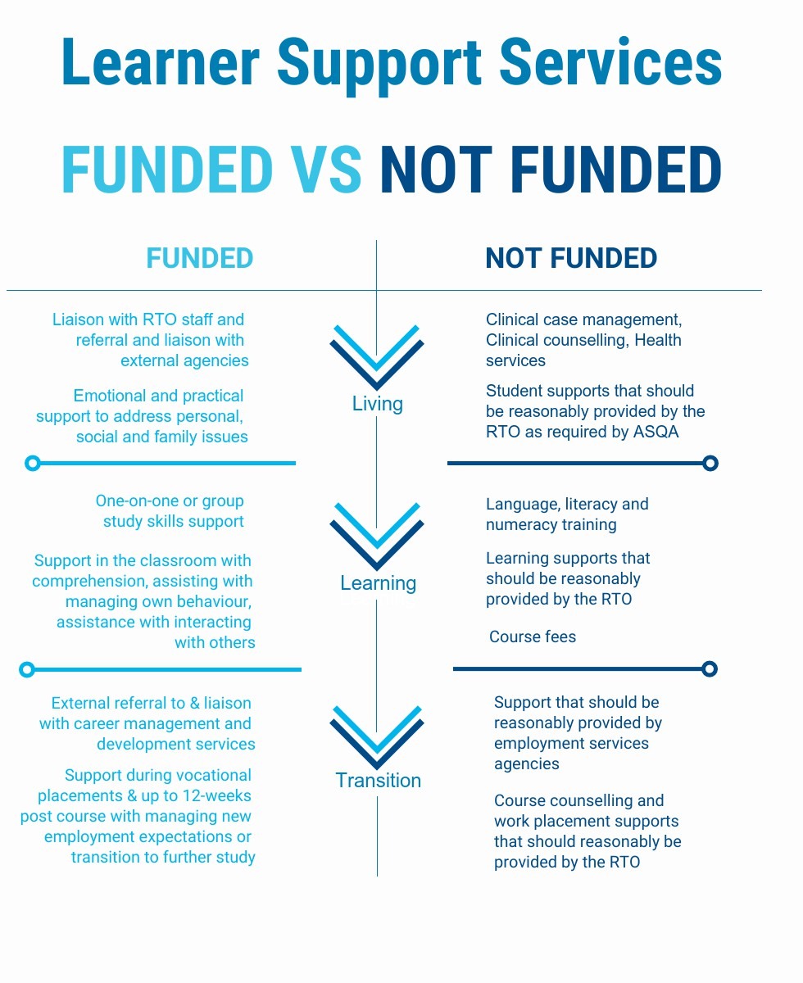

Appendix C

Learner Support Services (LSS) consent form
Consent to disclosure/exchange of personal information

Full name of student
Learner Support Services (LSS) is designed to provide participants with one-on-one support while studying with the aim of helping to deal with life, learning and transition issues affecting their studies. To provide coordinated support and monitor the participant success, agreement from the participant is needed for LSS case managers to share information about the participant with relevant people and organisations.
As a participant in Learner Support Services, I agree to the South Australian Department for Education, Skills SA sharing my personal information, including my academic results and details of the support provided to me, with all parties involved in the LSS program for the purposes of:
- tracking my progress with my VET studies
- ensuring effective support is provided to me
- referring me to agencies who can provide me with more support or other related services
- tracking my progress with transitioning to further training and/or employment
- providing me with information about further training and/or employment opportunities.
- statistical analysis, evaluation and reporting for your participation in the LSS program.
Information held by Skills SA is subject to the ‘information privacy principles’ issued by the South Australian Department of Premier and Cabinet. I understand that personal information that has been collected, used and stored will be dealt with by Skills SA in accordance with the relevant privacy guidelines.
I understand the meaning of this form and agree to the use of my personal information as described above.
Signature |  |  | Date | DD / MM / YYYY
Note: If person giving consent is under 18 years of age, then the consent of their guardian is required
Full name of guardian
Signature |  |  | Date | DD / MM / YYYY
Personal information held by Skills SA is subject to the ‘information privacy principles’ issued by the South Australian Department of Premier and Cabinet and may only be used for the purpose in which it has been collected. “personal information” means information or an opinion (including information or an opinion forming part of a database), whether true or not, and whether recorded in a material form or not, about an individual whose identify is apparent, or can reasonably be ascertained, from the information or opinion.

Learner support services consent form Consent to disclosure/exchange of personal information
The following organisations or service providers are nominated as specifically included in the exchange of personal information between parties involved in the LSS program as needed and in accordance with the information provided on page one of this form:
Name of organisation/service provider 1
Name of organisation/service provider 2
Name of organisation/service provider 3

Student consent
I acknowledge that the above organisations are specifically noted as being included in the exchange of personal information about me for the purposes described on page one of this form.
Full name of student
Signature |  | Date | DD / MM / YYYY

Note: If person giving consent is under 18 years of age at the time of giving consent, then the consent of their guardian is required
Guardian consent
Full name of guardian
Signature |  | Date | DD / MM / YYYY

